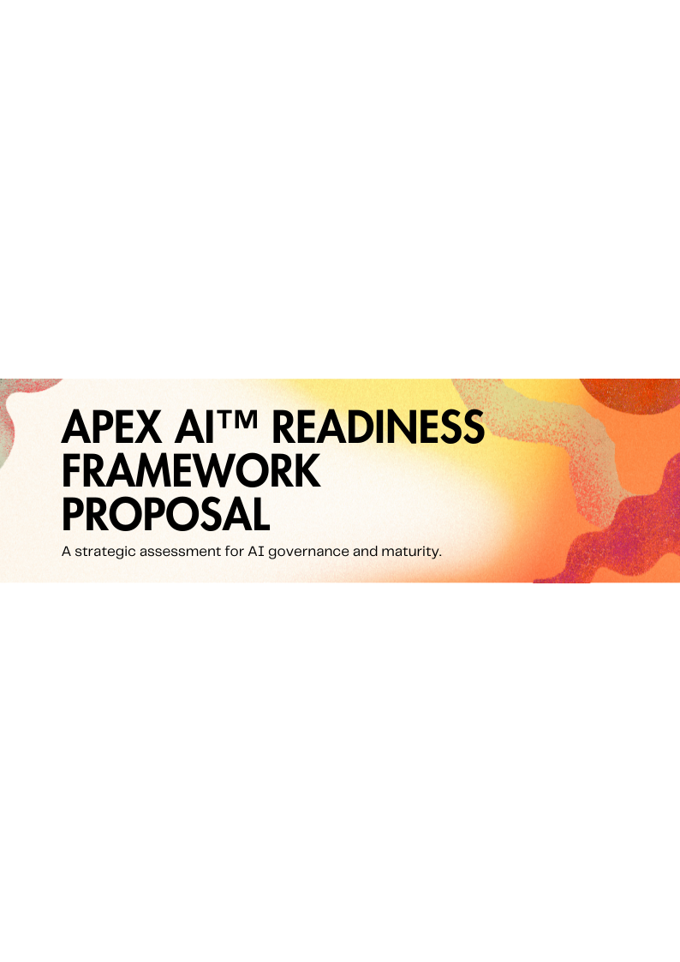
Executive Summary
This proposal outlines a structured engagement designed to assess your organization's readiness for Artificial Intelligence (AI) adoption and expansion. Apex AI™ Readiness Framework provides a clear roadmap for navigating the complexities of AI governance, mitigating potential risks, and maximizing the strategic value of AI investments. [MSP Name] offers a unique and commercially focused assessment that delivers actionable insights and fosters board-level confidence in your AI strategy.
Current State & Risk Context
Many organizations face challenges in effectively governing their AI initiatives, leading to increased risk exposure and unrealized potential. This includes:
- Lack of Strategic Alignment: AI projects not directly contributing to core business objectives.
- Governance Gaps: Insufficient policies and procedures for responsible AI development and deployment.
- Data Security & Privacy Concerns: Inadequate protection of sensitive data used in AI models.
- Ethical Considerations: Failure to address bias, fairness, and transparency in AI algorithms.
- Compliance Requirements: Non-compliance with evolving AI regulations and standards.
The Apex AI™ Readiness Framework addresses these critical challenges by providing a comprehensive assessment of your current state and identifying key areas for improvement.
Scope of Engagement
This engagement encompasses a thorough evaluation of your organization's AI governance framework, technical infrastructure, data management practices, and risk mitigation strategies. The assessment will cover the following key areas:
- AI Strategy & Governance: Alignment with business objectives, governance structures, and ethical considerations.
- Data Readiness: Data quality, availability, security, and compliance.
- Technical Infrastructure: Scalability, security, and performance of AI platforms and tools.
- Risk Management: Identification and mitigation of potential risks associated with AI deployment.
- Skills & Expertise: Availability of internal talent and expertise for AI development and management.
Apex AI™ Maturity Model Overview
The Apex AI™ Maturity Model provides a structured framework for assessing and improving your organization's AI capabilities. The model consists of five distinct stages:
- Ad-hoc: Limited AI adoption with no formal governance framework.
- Reactive: AI initiatives driven by specific needs with limited coordination.
- Defined: Established AI governance policies and procedures.
- Managed: Proactive management of AI risks and performance.
- Optimized: Continuous improvement and innovation in AI governance and deployment.
Assessment Methodology
Our assessment methodology combines a series of structured interviews, document reviews, and technical evaluations to provide a comprehensive understanding of your organization's AI readiness. The key steps include:
- Stakeholder Interviews: Engaging with key stakeholders across business and IT to gather insights and perspectives.
- Document Review: Reviewing existing policies, procedures, and technical documentation related to AI.
- Technical Assessment: Evaluating the security, scalability, and performance of your AI infrastructure.
- Gap Analysis: Identifying areas where your organization falls short of leading practices.
- Maturity Scoring: Assigning a maturity score based on the Apex AI™ Maturity Model.
Deliverables
Upon completion of the assessment, you will receive the following deliverables:
- Apex AI™ Readiness Report: A comprehensive report summarizing the findings of the assessment, including your organization's maturity score and key areas for improvement.
- Risk Assessment Report: A detailed analysis of potential risks associated with your AI initiatives, along with recommendations for mitigation.
- Actionable Roadmap: A prioritized roadmap outlining the steps required to achieve your desired level of AI maturity.
- Executive Presentation: A concise presentation summarizing the key findings and recommendations for executive leadership.
Commercial Investment
We offer flexible pricing options to align with your specific needs and budget. Below are example tiers:
- Tier 1: Foundation Assessment: [Placeholder Price] - Core readiness assessment with maturity scoring.
- Tier 2: Enhanced Assessment: [Placeholder Price] - Includes risk assessment and actionable roadmap.
- Tier 3: Comprehensive Assessment: [Placeholder Price] - Full assessment, roadmap, and executive presentation.
Note: Pricing is subject to final scoping and requirements.
Project Timeline
The project timeline will vary depending on the scope of the engagement. A typical assessment can be completed within [Placeholder Number] weeks. We will work closely with your team to establish a mutually agreeable timeline that minimizes disruption to your operations.
Why [MSP Name]?
[MSP Name] brings a unique blend of strategic consulting expertise and technical proficiency to AI governance. We are uniquely positioned to provide value because of:
- Proven Track Record: Successfully guided organizations through complex AI transformations.
- Deep Expertise: Subject matter experts in AI governance, risk management, and data security.
- Commercial Focus: Focused on delivering tangible business outcomes and maximizing ROI.
- Board-Level Communication: Experienced in presenting complex information in a clear and concise manner for executive audiences.
Terms & Next Steps
This proposal is valid for [Placeholder Number] days from the date of issuance. To proceed with the Apex AI™ Readiness Framework assessment, please review and sign the Acceptance Page. We look forward to partnering with you on your AI journey.
Acceptance Page
By signing below, you agree to the terms and conditions outlined in this proposal. Please provide the following information:
- Organization Name:
- Authorized Signature:
- Printed Name:
- Title:
- Date:
The Apex AI™ Readiness Framework empowers organisations to gain control of their AI initiatives. From current state, to future roadmap, this framework helps to clarify a path to future success in a rapidly changing environment.

